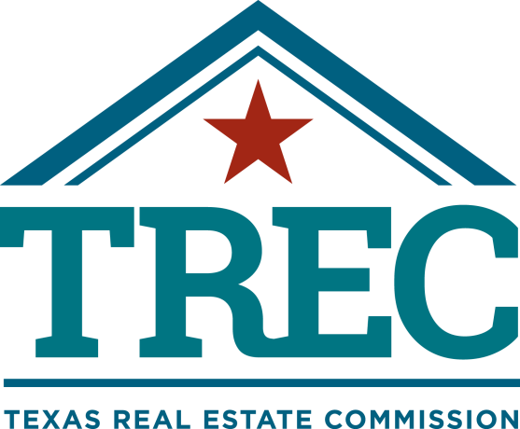

THE TEXAS REAL ESTATE COMMISSION (TREC) REGULATES
REAL ESTATE BROKERS AND SALES AGENTS, REAL ESTATE INSPECTORS, HOME WARRANTY COMPANIES, EASEMENT AND RIGHT-OF-WAY AGENTS AND TIMESHARE INTEREST PROVIDERS

YOU CAN FIND MORE INFORMATION AND CHECK THE STATUS OF A LICENSE HOLDER AT

WWW.TREC.TEXAS.GOV

YOU CAN SEND A COMPLAINT AGAINST A LICENSE HOLDER TO TREC
A COMPLAINT FORM IS AVAILABLE ON THE TREC WEBSITE

TREC ADMINISTERS TWO RECOVERY FUNDS WHICH MAY BE USED TO
SATISFY A CIVIL COURT JUDGMENT AGAINST A BROKER, SALES AGENT, REAL ESTATE INSPECTOR, OR EASEMENT OR RIGHT-OF-WAY AGENT,
IF CERTAIN REQUIREMENTS ARE MET

IF YOU HAVE QUESTIONS OR ISSUES ABOUT THE ACTIVITIES OF A LICENSE HOLDER, THE COMPLAINT PROCESS OR THE
RECOVERY FUNDS, PLEASE VISIT THE WEBSITE OR CONTACT TREC AT

TEXAS REAL ESTATE COMMISSION
P.O. BOX 12188
AUSTIN, TEXAS 78711-2188
(512) 936-3000

